[ Title: express your work in a concise and short title ]

Low temperature sintering (LOTUS) of inkjet printed metal precursor inks for organic electronic applications

[Authors: list the authors with the presenting speaker underlined

and a superscripted number for their affiliation ]

Jolke Perelaer,^{1,2*} Sebastian Wünscher,^{1,2} Franziska M. Wolf,^{1,2} Robert Abbel,³ Michael Groucho,⁴
Shlomo Magdassi,⁴ Ulrich S. Schubert^{1,2*}
[ List the affiliations in number of appearance along from the authors;
Company, Address, Zip code, City, Country ]
¹ Laboratory of Organic and Macromolecular Chemistry (IOMC), Friedrich-Schiller-University Jena, Humboldtstr. 10, 07743 Jena, Germany.
² Jena Center for Soft Matter (JCSM), Friedrich-Schiller-University Jena,
Humboldtstr. 10, 07743 Jena, Germany.
³ Holst Centre, High Tech Campus 31, 5656 AE Eindhoven, The Netherlands,
⁴ Casali Institute for Applied Chemistry, Institute of Chemistry, The Hebrew University of Jerusalem, Jerusalem 91904, Israel.
[ e-mail address and website ]
E-mail: jolke.perelaer@uni-jena.de and ulrich.schubert@uni-jena.de
Internet: http://www.schubert-group.com

[ Introduction; 1 paragraph, 200-300 words: introduce the topic and some literature background, include references that are summarized at the end of the paper. ]
Within the last decade, inkjet printing technology has developed from only a text and graphic industry to a major topic of scientific research and R&D. Inkjet printing can be used as a flexible, non-contact and digital patterning technique to print at high speeds either small or large areas with high quality features; it requires only small amounts of functional materials, which enables a simple form of processing as well as a cost-effective production.^{[1-3]} Furthermore, inkjet printing reduces the amount of processing steps due to its additive technique of materials deposition, which further decreases productions costs.
In the last years, inkjet printing of inorganic nanoparticles has gained an increased interest, because of the possible applications as contacts and interconnects in radio frequency identification (RFID) tags, organic light emitting diodes (OLED) and organic photovoltaics (OPV).^{[4,5]} The main challenges of using inorganic nanoparticles, for example silver, as precursor materials are a low conversion temperature that is compatible with common polymer foils as well as a fast conversion time that enables roll-to-roll (R2R) processing. Promising alternative sintering techniques include plasma,^{[6]} photonic^{[7]} and microwave flash sintering.^{[8]} Furthermore, more cost-efficient materials should be chosen, such as copper or aluminium,^{[9]} as the price for silver is continuously increasing. Such materials, however, require a protective atmosphere, as oxidation may take place under ambient conditions, which complicates the process and increases the manufacturing costs.
[ Main body of the paper; Goal of the current contribution, what is the difference with previous work, report in a clear and concise manner new results and data. Write at least 200 words. ]
The goal of the EU FP7 funded project called "LOTUS", which is an acronym for "LOw TemperatUre Sintering", is to develop new materials and sintering methods for printed electronics applications. The focus is to prepare metal precursor dispersions that can be easily inkjet printed and subsequently sintered at low temperatures (<150 °C). The sintering process should be compatible with cost-effective polymer foils and should take place in short times, in order to be compatible with R2R processing.
In this contribution, we will provide an overview the latest results obtained in the LOTUS project, including the low temperature conversion of inkjet printed metal precursor on cost-effective polymer foils. A variety as well as a combination of sintering tools were used, including photonic, plasma and microwave flash sintering in order to sinter at R2R speed. A particular focus is on high-throughput sintering, while yielding a high conductivity. Amongst the metal precursor materials are not only the commonly used silver nanoparticles, but also air-sensitive copper complexes or nanoparticles. Finally, demonstrators for OLED, OPV and RFID applications will be presented.
[ Figure; Place one figure that is clearly relevant to the topic; take care of proper resolution and readability. Add a caption below the figure that explains the figure. ]

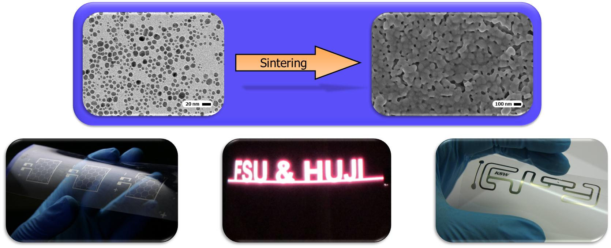
Figure 1. Top: process of sintering, where a metal nanoparticle ink (left: transmission electronic microscopy (TEM) image) is converted into a continuous and conductive structure (right: scanning electronic microscopy (SEM) image). Bottom: various applications for inkjet printed and sintered metallic structures, including (from left to right) current collector grids for organic photovoltaics (OPV),^{[7]} an electroluminescent device^{[10]} and a radio frequency identification (RFID) tag.^{[4]}
Keywords
[ choose the most relevant keywords, but no more than 3, that describe your results. ]
[ here comes the list of keywords that were presented at the meeting on Friday 14th June ]

Biography
[ add the presenting author's biography in up to 100 words. ]
Jolke Perelaer obtained his masters in chemistry at the University of Utrecht in the Netherlands in 2004. He finished his PhD within the group of Prof. Schubert (Eindhoven University of Technology, the Netherlands, 2009) with the focus on the preparation of (conductive) microstructures via inkjet printing and embossing techniques. He continued his work with Prof. Schubert as project manager of the inkjet group at the Friedrich-Schiller-University in Jena, Germany. The topics include printed electronics, combinatorial materials screening and printed bio-materials.

References
[ add the most relevant references, but not more than 10. ]
[1] J. Perelaer, P. J. Smith, D. Mager, D. Soltman, S. K. Volkman, V. Subramanian, J. G. Korvink, U. S. Schubert, J. Mater. Chem. 2010, 20, 8446.
[2] M. Singh, H. M. Haverinen, P. Dhagat, G. E. Jabbour, Adv. Mater. 2010, 22, 673.
[3] J. Perelaer, U. S. Schubert, J. Mater. Res. 2013, 28, 564.
[4] F. M. Wolf, J. Perelaer, S. Stumpf, D. Bollen, F. Kriebel, U. S. Schubert, J. Mater. Res. 2013, in press.
[5] Y. Galagan, E. W. C. Coenen, R. Abbel, T. J. van Lammeren, S. Sabik, M. Barink, E. R. Meinders, R. Andriessen, P. W. M. Blom, Org. Electr. 2013, 14, 38.
[6] I. Reinhold, C. E. Hendriks, R. Eckardt, J. M. Kranenburg, J. Perelaer, R. R. Baumann, U. S. Schubert, J. Mater. Chem. 2009, 19, 3384.
[7] J. Perelaer, R. Abbel, S. Wünscher, R. Jani, T. van Lammeren, U. S. Schubert, Adv. Mater. 2012, 24, 2620.
[8] J. Perelaer, M. Klokkenburg, C. E. Hendriks, U. S. Schubert, Adv. Mater. 2009, 21, 4830.
[9] A. Kamyshny, J. Steinke, S. Magdassi, Open Appl. Phys. J. 2011, 4, 19.
[10] J. Perelaer, R. Jani, M. Grouchko, A. Kamyshny, S. Magdassi, U. S. Schubert, Adv. Mater. 2012, 24, 3993.

